AI-ML Based Intelligent de-smoking and de-hazing algorithm

BHAGYALAKSHMI  UG Scholar  School of Computer Science and Engineering Presidency University  BENGALURU, India  Roll No.: 20231ISE0115 | B.SAMRUDDHI  UG Scholar  School of Computer Science and Engineering Presidency University  BENGALURU, India  Roll No.: 20231ISE0117 | NEHA  UG Scholar  School of Computer Science and Engineering Presidency University  BENGALURU, India  Roll No.: 20231ISE0133

ABSTRACT
Haze and smoke can significantly reduce image visibility and affect the performance of computer vision systems used in outdoor and surveillance environments. This work proposes an AIML-based image restoration framework for dehazing and desmoking using an improved U-Net architecture. Real-world hazy images from the O-HAZE and NH-HAZE datasets are used to train the dehazing model, while SmokeBench is used for the desmoking experiment [1][2][8]. The proposed model uses an encoder-decoder structure with skip connections, batch normalization, ReLU activation, and dropout to learn the mapping between degraded and clear images. A combined L1 and SSIM-based loss is used to improve both pixel-level reconstruction and structural preservation. For the current dehazing experiment, 950 image patches of size 256 × 256 are generated from the training data. The model achieves an average PSNR of 22.40 dB and an SSIM of 0.8233 on five unseen O-HAZE test images. A separate desmoking experiment using a subset of SmokeBench is also conducted to evaluate the feasibility of smoke removal. The proposed framework provides a foundation for future integration with video processing and person detection for visual surveillance applications.
KEYWORDS
AIML, Image Dehazing, Image Desmoking, U-Net, O-HAZE, NH-HAZE, SmokeBench, Image Restoration, PSNR, SSIM.

I. INTRODUCTION
Haze and smoke are common causes of poor visibility in outdoor and surveillance images. They reduce contrast, hide important details, and can affect the performance of computer vision systems. Conventional image enhancement techniques may improve visibility to some extent, but they often struggle when the degradation is dense or unevenly distributed.
Recent deep learning methods have shown better potential for restoring degraded images by learning directly from paired degraded and clear images. Datasets such as O-HAZE and NH-HAZE provide real-world hazy and haze-free images for dehazing research [1][2]. Similarly, SmokeBench provides paired surveillance images for studying image desmoking [8].
In this work, an AIML-based image restoration framework is developed using an improved U-Net architecture. The model is trained for dehazing using O-HAZE and NH-HAZE data and separately evaluated for desmoking using SmokeBench. The restored images are evaluated using PSNR and SSIM, with the long-term goal of applying the system to video-based visual surveillance.
II. PROBLEM STATEMENT
Haze and smoke can severely degrade image quality and reduce the visibility of objects, edges, and scene details. This creates difficulties for both human observation and automated computer vision systems. A restoration method is therefore required that can learn from real degraded images and recover clearer visual information while preserving important structural details. The challenge is to develop a single practical framework that can investigate both dehazing and desmoking using real-world datasets.
III. OBJECTIVES
The main objective of this work is to develop an AIML-based framework for improving the visibility of hazy and smoke-affected images. The study aims to train an improved U-Net model using real-world dehazing datasets, evaluate its performance on unseen O-HAZE test images, and investigate a similar restoration approach for smoke removal using SmokeBench. The performance of the models is measured using PSNR and SSIM. The work also provides a foundation for future integration with video processing and person detection for surveillance applications.
IV. PROPOSED WORK
The proposed system uses an improved U-Net model to learn the transformation from degraded images to clearer images. O-HAZE and NH-HAZE are used for training the dehazing model because they contain real-world haze conditions [1][2]. The available training images are divided into 256 × 256 patches to provide more training samples. The model uses an encoder-decoder structure with skip connections to preserve both contextual information and fine image details. L1 loss combined with SSIM loss is used during training to improve pixel-level accuracy and structural similarity.
For desmoking, a separate U-Net-based experiment is performed using SmokeBench [8]. The restored outputs are evaluated using PSNR and SSIM to measure reconstruction quality. The current implementation focuses mainly on validating the image restoration models, while video processing, person detection, and a Streamlit-based interface are considered future extensions of the complete system.
V. SYSTEM DESIGN
The system design divides the proposed image restoration framework into separate functional modules so that data preparation, restoration, and evaluation can be performed independently. The input images are first collected from real-world dehazing and desmoking datasets and prepared for model training. The processed images are then given to the improved U-Net model, which learns to restore degraded images while preserving important visual details. The overall architecture consists of dataset preparation, preprocessing, model training, image restoration, and performance evaluation modules. O-HAZE and NH-HAZE are used for the dehazing stage, while SmokeBench is used for the desmoking experiment [1][2][8].

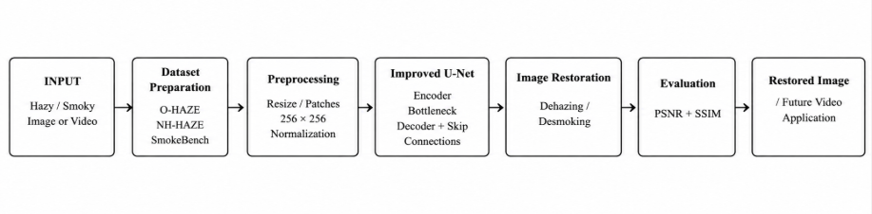
Fig 1:Architectureof the proposed AIML based dehazing and desmoking system

A. Input and Dataset Module
The input module consists of real-world hazy and smoke-affected images. O-HAZE and NH-HAZE provide paired hazy and haze-free images for training the dehazing model [1][2]. SmokeBench provides paired smoke-affected and clear images for the desmoking experiment [8]. Each degraded image is associated with a corresponding ground-truth image, allowing supervised learning.
B. Preprocessing Module
The preprocessing module prepares the images before they are supplied to the neural network. Since the original images have different resolutions, training samples are generated as 256 × 256 image patches. Random cropping and flipping are applied to increase the variety of training samples. The images are converted into tensors and normalized to values between 0 and 1 before being passed to the model.
C. Dehazing and Desmoking Model
The restoration module uses an improved U-Net architecture based on an encoder-decoder structure with skip connections [3]. The encoder extracts features from the degraded image, while the decoder reconstructs the restored image. Batch normalization, ReLU activation, and dropout are included to improve training stability and reduce overfitting. The same general U-Net approach is used separately for the dehazing and desmoking experiments, with each model trained using its respective dataset.

D. Loss and Optimization Module
During training, the predicted restored image is compared with the corresponding ground-truth image. The proposed dehazing model uses a combination of L1 loss and SSIM-based loss so that both pixel-level differences and structural information are considered. The Adam optimizer is used with a learning rate of 0.0001. The model with the lowest validation loss is saved and used for final testing.
E. Evaluation Module
The evaluation module measures the quality of the restored images using Peak Signal-to-Noise Ratio (PSNR) and Structural Similarity Index Measure (SSIM). The trained dehazing model is evaluated on five unseen O-HAZE test images to examine its ability to restore images that were not used during training. Visual comparison between degraded, restored, and ground-truth images is also used to observe changes in visibility, structure, and image quality.
F. Application Layer
The current implementation mainly focuses on image restoration and quantitative evaluation. The planned application layer extends the system to image and video input, where restored frames can subsequently be processed by a person-detection module. A Streamlit-based interface can be used to provide image or video upload, restoration, visualization, and output download functionality. These components are considered future extensions of the current experimental system.

VI. IMPLEMENTATION
The proposed system was implemented using Python and the PyTorch deep learning framework. The datasets were organized into separate input and ground-truth folders, and the O-HAZE and NH-HAZE images were used to prepare training samples for dehazing. The images were divided into 256 × 256 patches and converted into tensors with normalized pixel values between 0 and 1. Random cropping and flipping were used during data preparation to provide additional variation in the training samples.
The improved U-Net model was implemented with four encoder stages, a bottleneck layer, and a corresponding decoder with skip connections. Convolutional layers were combined with batch normalization and ReLU activation, while dropout was applied at the bottleneck. The output layer produces a three-channel RGB image using sigmoid activation. The model was trained using the Adam optimizer with a learning rate of 0.0001 and a batch size of 8.
For dehazing, a combined L1 and SSIM-based loss was used to consider both pixel-level reconstruction and structural similarity. The model was trained for 20 epochs, and the validation loss was monitored after each epoch. The best model was obtained at epoch 18 with a validation loss of 0.2273 and was saved for final testing. The trained model was evaluated on five unseen O-HAZE test images using PSNR and SSIM.
A separate U-Net-based experiment was also implemented for desmoking using the SmokeBench dataset. The current experiment used a subset of the available data to study the feasibility of smoke removal. The trained restoration models form the main implementation of the current work, while video processing, person detection, and the Streamlit interface are planned as extensions for the complete application.

VII. DATA AND INFORMATION FLOW
The data flow begins with the collection of paired degraded and ground-truth images from the O-HAZE, NH-HAZE, and SmokeBench datasets. The hazy images from O-HAZE and NH-HAZE are processed and divided into 256 × 256 patches for dehazing model training, while SmokeBench data is used separately for the desmoking experiment. The preprocessed images are converted into tensors and provided to the improved U-Net model. During training, the predicted output is compared with the ground-truth image using the selected loss function, and the model weights are updated through the Adam optimizer. After training, the best model is used to restore unseen test images. The restored images are then evaluated using PSNR and SSIM to measure reconstruction quality. The resulting flow provides a clear connection between the input data, preprocessing, model training, restoration, and final evaluation.

TABLE I
DATASET AND PROCESSING DETAILS
Dataset | Purpose | Data Used | Processing
O-HAZE | Dehazing | 40 train pairs, 5 test pairs | 256 × 256 patches
NH-HAZE | Dehazing | 55 paired scenes | 256 × 256 patches
SmokeBench | Desmoking | 1000 train, 100 test pairs* | Image-based training
Combined Dehazing Data | Model training | 950 input + 950 GT patches | Train/validation split

INFORMATION FLOW
The information flow can be represented as:
Degraded Image → Preprocessing → U-Net Model → Restored Image → PSNR/SSIM Evaluation
For the dehazing experiment, O-HAZE and NH-HAZE data are combined during training, while the original O-HAZE test images are kept separate for final evaluation. The same general restoration approach is applied separately to SmokeBench for desmoking. This separation allows the performance of each restoration task to be examined independently.
VIII. RESULTS AND DISCUSSION
The proposed models were evaluated using both quantitative metrics and visual comparisons. For dehazing, the trained model was tested on five O-HAZE test images that were not used during training. PSNR and SSIM were used to measure restoration quality, while visual comparisons were used to examine haze removal and preservation of scene details. A separate experiment was also conducted using SmokeBench to study the effectiveness of the U-Net model for smoke removal.
A. Training and Validation Performance
The dehazing model was trained for 20 epochs using the combined O-HAZE and NH-HAZE training data. The training loss decreased from 0.3444 in the first epoch to approximately 0.2590 by the final epoch. The validation loss also showed an overall decreasing trend, reaching its lowest value of 0.2273 at epoch 18. The small fluctuations observed in the validation curve indicate that the model did not improve uniformly at every epoch. Since the lowest validation loss was obtained at epoch 18, this checkpoint was selected as the final dehazing model rather than using the model from the last epoch.
B. Quantitative Dehazing Results
The trained model was evaluated on five O-HAZE test images using PSNR and SSIM. The PSNR values obtained were 24.80 dB, 23.46 dB, 23.59 dB, 17.42 dB, and 22.74 dB for images 36 to 40, respectively. The average PSNR was 22.40 dB and the average SSIM was 0.8233. These results indicate that the model was able to reduce haze while maintaining a considerable amount of the original scene structure. Image 39 produced the lowest PSNR, showing that the restoration quality can vary depending on the difficulty and visual characteristics of the input scene.
B. Quantitative Dehazing Results
The trained model was evaluated on five O-HAZE test images using PSNR and SSIM. The PSNR values obtained were 24.80 dB, 23.46 dB, 23.59 dB, 17.42 dB, and 22.74 dB for images 36 to 40, respectively. The average PSNR was 22.40 dB and the average SSIM was 0.8233. These results indicate that the model was able to reduce haze while maintaining a considerable amount of the original scene structure. Image 39 produced the lowest PSNR, showing that the restoration quality can vary depending on the difficulty and visual characteristics of the input scene.

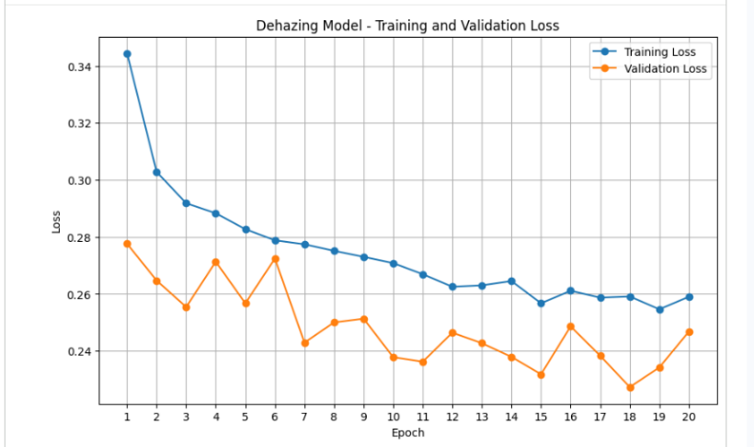
Fig 2: Training and validation graph of Dehazing model
B. Quantitative Dehazing Results
The trained model was evaluated on five O-HAZE test images using PSNR and SSIM. The PSNR values obtained were 24.80 dB, 23.46 dB, 23.59 dB, 17.42 dB, and 22.74 dB for images 36 to 40, respectively. The average PSNR was 22.40 dB and the average SSIM was 0.8233. These results indicate that the model was able to reduce haze while maintaining a considerable amount of the original scene structure. Image 39 produced the lowest PSNR, showing that the restoration quality can vary depending on the difficulty and visual characteristics of the input scene.

TABLE II
DEHAZING RESULTS ON O-HAZE TEST IMAGES
Test Image | PSNR (dB) | SSIM
36.png | 24.80 | 0.8640
37.png | 23.46 | 0.8245
38.png | 23.59 | 0.8356
39.png | 17.42 | 0.7658
40.png | 22.74 | 0.8264
Average | 22.40 | 0.8233

C. Qualitative Dehazing Results
The visual results show a clear difference between the original hazy images and the restored outputs. In the first test image, the output recovers details in the stone structure, vegetation, and surrounding objects that are less visible in the hazy input. Similar improvements can be observed in images 37 and 38, where the restored outputs provide better visibility of the trees, ground, and playground structures. The outputs are visually closer to the corresponding ground-truth images, although some differences in brightness and color can still be observed. This indicates that the model is able to remove a substantial amount of haze while retaining important scene structures.
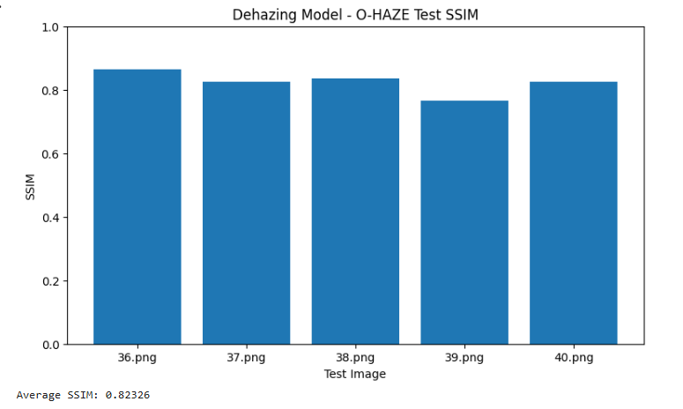
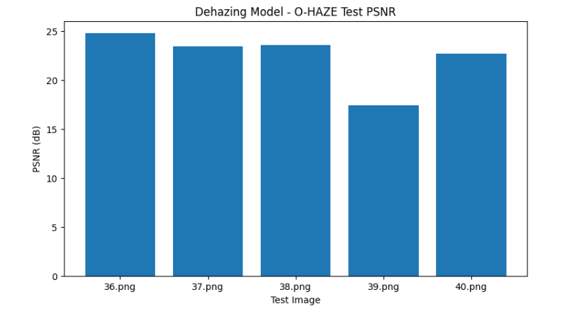
Fig 3: Graph for SSIM and PSNR ration for dehazing model.

D. Unseen-Test Data Evaluation
To verify that the model was not evaluated on images used during training, the O-HAZE training and test directories were checked separately. The training set contained 40 images, while the test set contained five images.The overlap check produced zero common images between the two sets. Therefore, the reported test results represent evaluation on previously unseen O-HAZE images. This provides evidence that the trained model can perform restoration beyond the images directly used for model training.
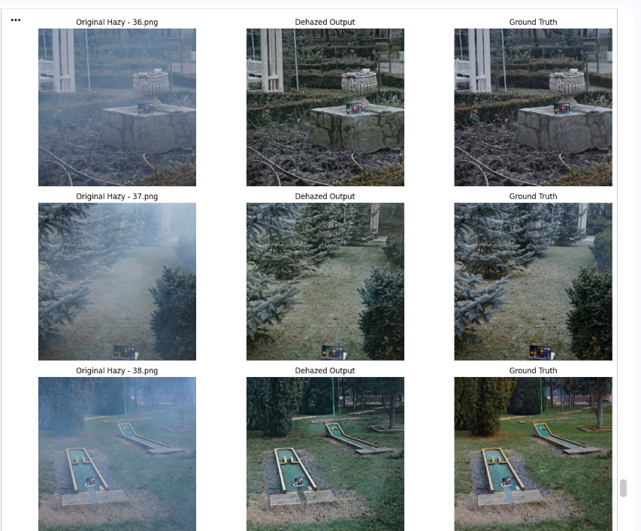
Fig 4: Image dehazing results on test datasets.

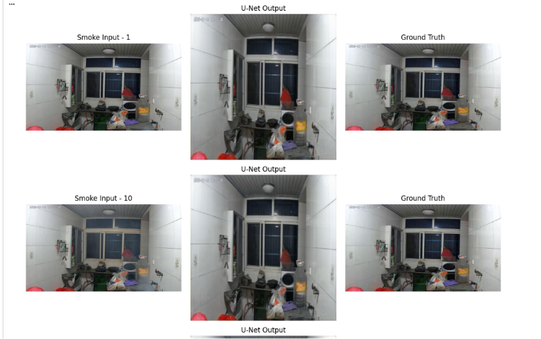
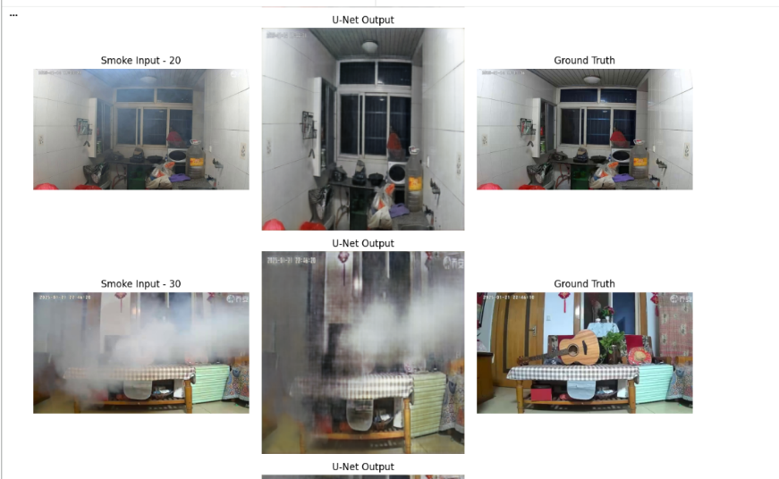
Fig 5: Image de-smoking results on test datasets

F. Overall Discussion
The experimental results show that the improved U-Net provides useful restoration performance for both haze and smoke degradation. The dehazing experiment produced an average PSNR of 22.40 dB and an SSIM of 0.8233 on the five unseen O-HAZE test images, with the visual outputs showing noticeable improvement in scene visibility. The desmoking experiment also produced visually improved outputs, although dense smoke remained challenging for the model.
The results also show that PSNR and SSIM do not always change in exactly the same way. PSNR mainly measures pixel-level reconstruction error, whereas SSIM focuses more on structural similarity. Therefore, a change in one metric does not necessarily imply the same change in the other. The qualitative results are consequently considered along with the numerical metrics when assessing restoration quality.
Overall, the current experiments establish the image-restoration component of the proposed system. The main limitations observed are residual artifacts in heavily degraded images, differences in color or brightness in some dehazed outputs, and the limited subset used for the current desmoking experiment. These observations provide a basis for further improvement using larger training data, better data splitting, and more advanced restoration architectures.

XI. LIMITATIONS AND FUTURE SCOPE
A. Limitations
The current study has some limitations that should be considered when interpreting the results. The dehazing model was trained using a relatively limited number of source images from O-HAZE and NH-HAZE, with additional 256 × 256 patches generated for training. The validation set was created at the patch level, so patches originating from the same source image may occur in both training and validation data. Therefore, the validation result should not be considered strict image-level generalization evidence. In addition, the current desmoking experiment uses only a reduced subset of SmokeBench rather than the complete dataset. The results also show that heavily degraded images can contain residual smoke, blur, or differences in brightness and color after restoration. The present implementation mainly focuses on image restoration and does not yet include the complete video processing and surveillance pipeline.
B. Future Scope
The proposed work can be extended by training the models using the complete available datasets and using source-image-level separation for training and validation. More advanced image restoration architectures and additional loss functions can also be investigated to improve the reconstruction of heavily degraded scenes. The desmoking model can be further trained and evaluated using the complete SmokeBench dataset to obtain a more comprehensive performance analysis. The restoration models can also be integrated with video processing so that individual video frames can be dehazed or desmoked in real time. A person-detection module can then be added after restoration to improve object visibility in surveillance scenes. Finally, a Streamlit-based application can be developed to allow users to upload images or videos, view the original and restored results, and download the processed output.

XII. CONCLUSION
This work presents an AIML-based image restoration framework for dehazing and desmoking using an improved U-Net architecture. The dehazing model achieved an average PSNR of 22.40 dB and SSIM of 0.8233 on five unseen O-HAZE test images, showing effective haze removal and preservation of image structure. The desmoking experiment also demonstrated the ability to recover visual information from smoke-affected images, although dense smoke remains challenging. The proposed framework provides a foundation for future video-based restoration, person detection, and an interactive Streamlit application

TABLE III
SYSTEM AREAS AND EXPECTED BEHAVIOR
Area | Expected Behavior
Input | Accept hazy or smoke-affected images
Preprocessing | Prepare and normalize images for the model
Dehazing | Reduce haze and improve scene visibility
Desmoking | Reduce smoke and recover visible details
U-Net Model | Learn restoration from degraded and ground-truth images
Evaluation | Measure restoration quality using PSNR and SSIM
Video Processing | Process degraded video frames in future implementation
Person Detection | Detect visible persons after image restoration
Streamlit Interface | Provide a simple interface for uploading and viewing results

XIII. REFERENCES
[1] C. O. Ancuti, C. Ancuti, R. Timofte, and C. De Vleeschouwer, “O-HAZE: A Dehazing Benchmark With Real Hazy and Haze-Free Outdoor Images,” Proceedings of the IEEE/CVF Conference on Computer Vision and Pattern Recognition Workshops, pp. 754–762, 2018.
[2] C. O. Ancuti, C. Ancuti, and R. Timofte, “NH-HAZE: An Image Dehazing Benchmark With Non-Homogeneous Hazy and Haze-Free Images,” Proceedings of the IEEE/CVF Conference on Computer Vision and Pattern Recognition Workshops, pp. 444–445, 2020.
[3] O. Ronneberger, P. Fischer, and T. Brox, “U-Net: Convolutional Networks for Biomedical Image Segmentation,” in Medical Image Computing and Computer-Assisted Intervention (MICCAI), pp. 234–241, 2015.
[4] B. Cai, X. Xu, K. Jia, C. Qing, and D. Tao, “DehazeNet: An End-to-End System for Single Image Haze Removal,” IEEE Transactions on Image Processing, vol. 25, no. 11, pp. 5187–5198, 2016.
[5] B. Li, X. Peng, Z. Wang, J. Xu, and D. Feng, “AOD-Net: All-in-One Dehazing Network,” in Proceedings of the IEEE International Conference on Computer Vision (ICCV), pp. 4770–4778, 2017.
[6] X. Qin, Z. Wang, Y. Bai, X. Xie, and H. Jia, “FFA-Net: Feature Fusion Attention Network for Single Image Dehazing,” Proceedings of the AAAI Conference on Artificial Intelligence, vol. 34, no. 07, pp. 11908–11915, 2020.
[7] C. Ancuti, C. O. Ancuti, R. Timofte, and C. De Vleeschouwer, “NTIRE 2018 Challenge on Image Dehazing: Methods and Results,” Proceedings of the IEEE/CVF Conference on Computer Vision and Pattern Recognition Workshops, pp. 891–901, 2018.
[8] W. Jin, Q. Yang, X. Wu, H. Chen, P. Li, and X. Chen, “SmokeBench: A Real-World Dataset for Surveillance Image Desmoking in Early-Stage Fire Scenes,” arXiv preprint arXiv:2509.12701, 2025.
[9] W. Ren, S. Liu, H. Zhang, J. Pan, X. Cao, and M.-H. Yang, “Single Image Dehazing via Multi-Scale Convolutional Neural Networks,” in European Conference on Computer Vision (ECCV), pp. 154–169, 2016.
[10] H. Zhang and V. M. Patel, “Densely Connected Pyramid Dehazing Network,” in Proceedings of the IEEE/CVF Conference on Computer Vision and Pattern Recognition (CVPR), pp. 3194–3203, 2018.
[11] H. Zhang, V. Sindagi, and V. M. Patel, “Multi-Scale Single Image Dehazing Using Perceptual Pyramid Deep Network,” in Proceedings of the IEEE/CVF Conference on Computer Vision and Pattern Recognition Workshops, 2018.
[12] X. Dong, Y. Yan, W. Li, and L. Duan, “Multi-Scale Boosted Dehazing Network with Dense Feature Fusion,” in Proceedings of the IEEE/CVF Conference on Computer Vision and Pattern Recognition Workshops, 2020.
[13] W. Wu et al., “Contrastive Learning for Compact Single Image Dehazing,” in Proceedings of the IEEE/CVF Conference on Computer Vision and Pattern Recognition, 2021.
[14] C. O. Ancuti, C. Ancuti, F.-A. Vasluianu, and R. Timofte, “NTIRE 2020 Challenge on NonHomogeneous Dehazing,” Proceedings of the IEEE/CVF Conference on Computer Vision and Pattern Recognition Workshops, pp. 490–491, 2020.
[15] Z. Wang, A. C. Bovik, H. R. Sheikh, and E. P. Simoncelli, “Image Quality Assessment: From Error Visibility to Structural Similarity,” IEEE Transactions on Image Processing, vol. 13, no. 4, pp. 600–612, 2004.

